Step by Step – How to Install Docker in Windows 10

In this document, I will show you how to install Docker in Windows 10. We will be using community edition (CE) as this is a free version. You can use this edition to install it on your personal computer to learn and build application around it.

**Prerequisites:** Docker requires Hyper-V enabled in Windows 10. Without this Docker will not run after you install Docker. To enable Hyper-V in Windows, please follow my post [here](https://www.shaileshjha.com/how-to-install-setup-and-configure-hyper-v-in-windows-10/). To enable Hyper-V in Windows, you will have to enable Virtualization in BIOS. To do that please follow my post [here](https://www.shaileshjha.com/step-by-step-guide-to-enable-intel-vt-x-or-amd-v-in-bios-or-uefi-in-windows-10-and-windows-8/).

Please note that Docker needs Hyper-V only in Windows 10. It will not work with VMware Workstation or Virtual Box. You can refer to the docker documentation [here](https://docs.docker.com/docker-for-windows/install/).

Step 1 – Download Docker

Officially Docker installer can be downloaded from [Docker Store](https://store.docker.com/editions/community/docker-ce-desktop-windows) only. You will have to create an account to be able to download it. Having an account for Docker is a very good things. It allows you to download docker images in the future.

If you dont want to create an account, this is the [**direct link to Download Docker Installer**](https://download.docker.com/win/stable/Docker%20for%20Windows%20Installer.exe)**.**

You can also reach the Docker Store download page from the Docker official page. Go to the [Docker Official home Page](https://www.docker.com/). Click on Get Started button on to right side of the page. In the page that opens, under IT tab, click on Docker for Windows. This will take you to the Docker Store.

The installer file for windows is around 516 MB.

Step 2 – Run the installer

Double click on the downloaded installer file to start the installation wizard. You will see Windows UAC – User Access Control asking for permission to allow the program to run. Click yes to continue.

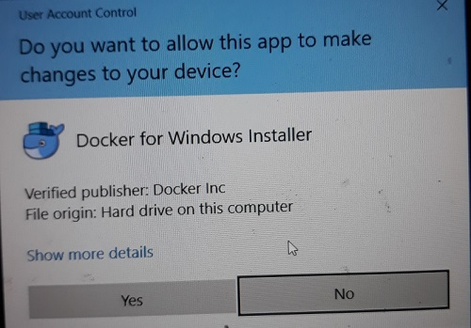

Docker Installation – Windows User Access Control

Now you will see Docker installer downloading additional files required. If you dont have internet connection, installer will move on to the next step. Wait for the process to complete and you will see the configuration screen.

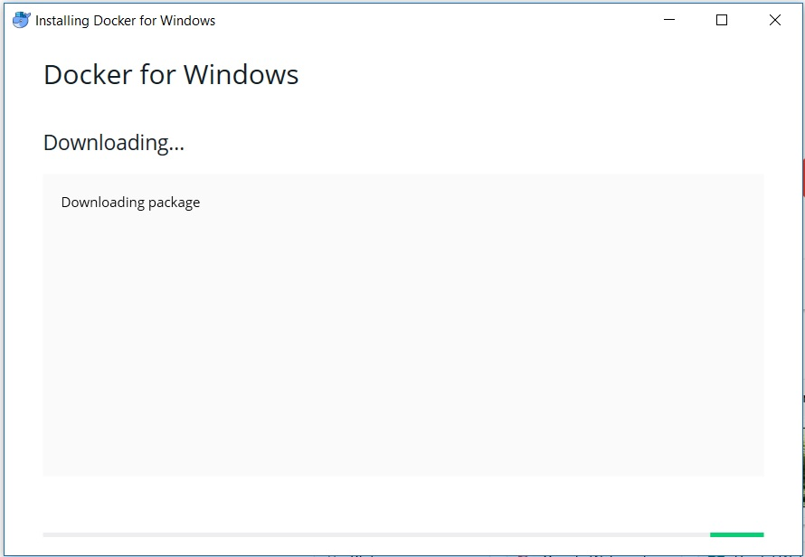

Docker Installation

Step 3 – Configuration Settings

In this dialog box you will be asked if you want to create desktop icon for Docker. I leave this checked. Second option is if you want to use Linux or Windows Container. This option can be changed later on. I leave it as default, that is unchecked.

Containers run on your host operating system which can be Linux or Windows. Ideally you can run Linux container on Linux OS and Windows container on Windows OS. This could be a problem in development machines if you want to develop linux container based application on Windows.  
To get around this, Docker allow users to create both linux and windows container on the same windows machine without having to switch between OS platforms. To achieve this, Docker provides a Linux VM for Hyper-V called MobyLinuxVM as a part of installation process. This VM runs Linux container and your Windows 10 host runs Windows Containers. You cannot run both Windows and Linux Containers at the same time. That is why Docker allows you to switch between Windows and Linux container.  
With this you can run both Linux and Windows Containers side by side as a part of the same Docker Installation for Windows.

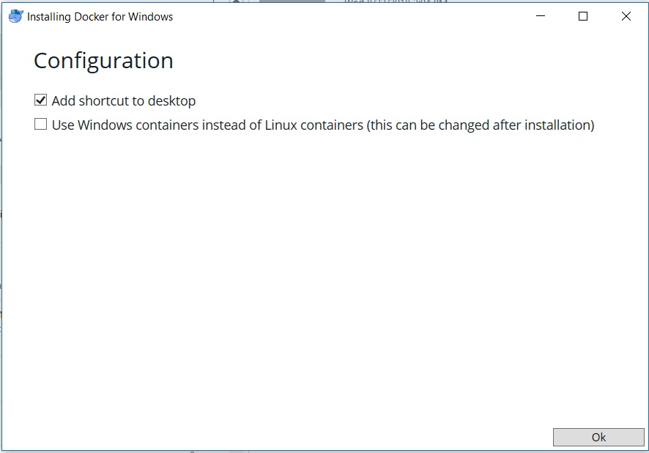

Docker Installation – Configuration settings

Click OK to start the installation. Wait for the installation to complete.

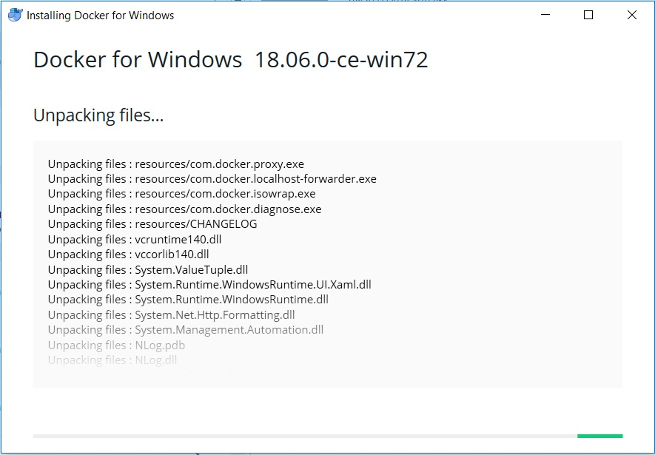

Docker Installation

Once the installation completes, click on Close to complete the installation.

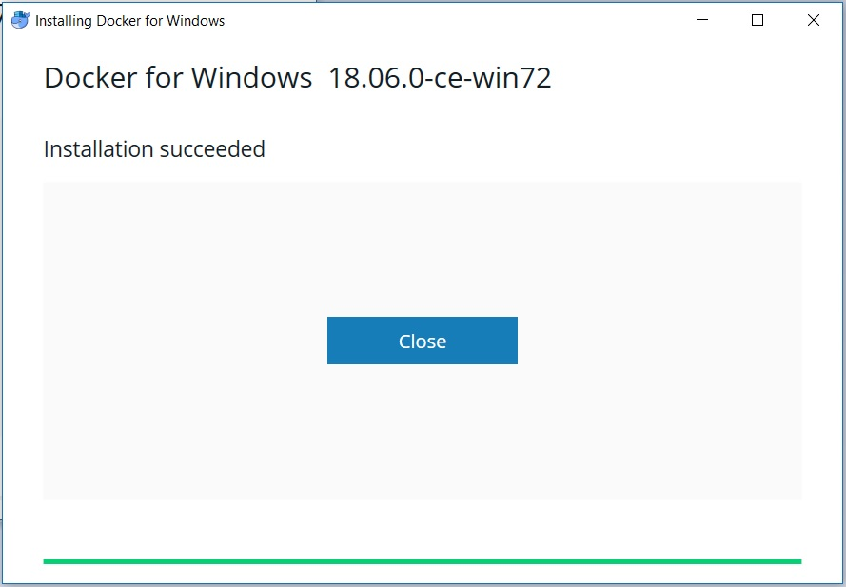

Docker Installation Complete Screenshot

Step 4 – Run Docker

Once the installation completes run Docker by double clicking the icon created on the desktop or from start menu. You will see a docker icon appear on your windows task bar. If you hover your mouse over it, it will say “Docker is Starting”. Wait for Docker to start.

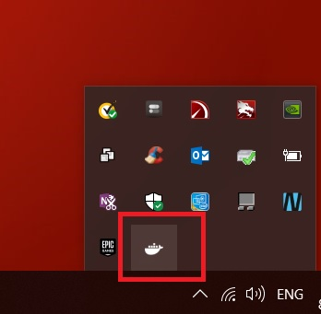

Docker Icon – Windows task bar

Step 5 – Disable Start Docker at Startup

By default, docker will automatically start when you turn on/login to your computer. Since Docker requires a lot of RAM, I don’t recommend this. We can start docker manually when we want to use it.

To disable starting docker at startup, right click on the docker Icon in the task bar. Click on Settings, under General Tab, uncheck, Start Docker when you login.

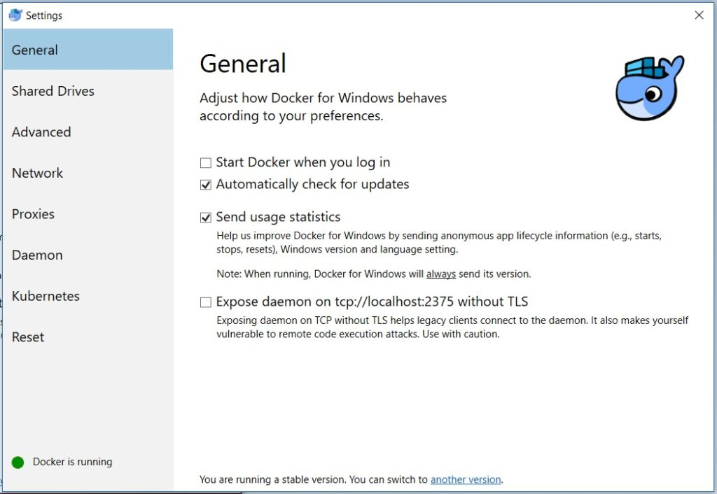

Docker Settings

Step 6 – Check the version of Docker Installed

Most of the time you will be working with command line to work with Docker. Let this be your first command to check Docker version and see what you get.  
Open Powershell or command prompt and enter the command:  
docker version  
You should see something like this.

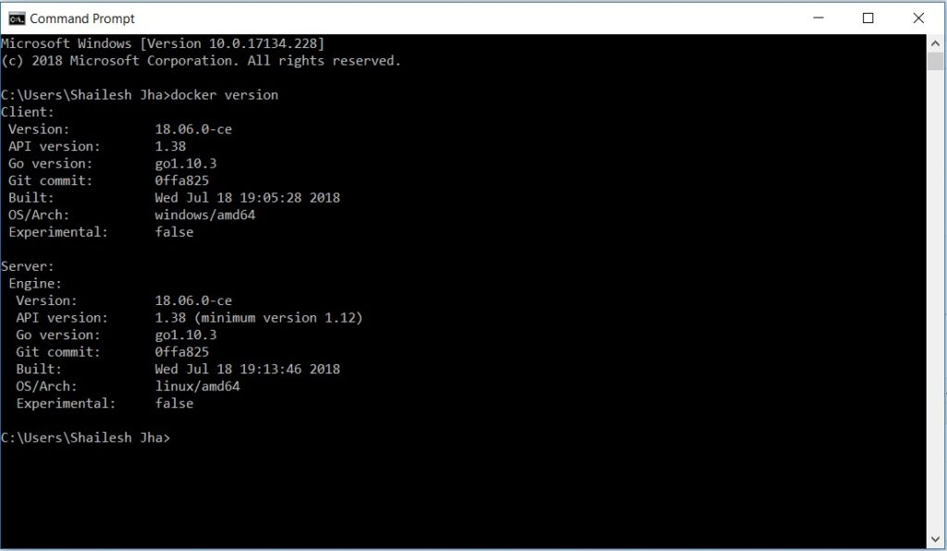

Docker – Check version – command line interface

That’s it for now. Happy reading & practicing